REACT ASSIGNMENTS
Assignment 12:
Aim: To develop a React application that demonstrates conditional rendering by displaying different pages for Guest and User. The application also displays flight details using reusable React components.
Components Created
• App.js
• GuestPage.js
• UserPage.js
• FlightDetails.js
1. App.js
import React from "react";
import GuestPage from "./GuestPage";
import UserPage from "./UserPage";

function App() {

const isLoggedIn = false;

return (
<div
style={{
textAlign: "center",
marginTop: "30px"
}}
>
<h1>Ticket Booking Application</h1>

{
isLoggedIn
? <UserPage />
: <GuestPage />
}

</div>
);
}

export default App;

2. FlightDetails.js
import React from "react";

function FlightDetails() {

const flights = [
{
id: 1,
flightName: "IndiGo",
source: "Kolkata",
destination: "Delhi",
fare: 5500
},
{
id: 2,
flightName: "Air India",
source: "Mumbai",
destination: "Chennai",
fare: 4800
},
{
id: 3,
flightName: "SpiceJet",
source: "Bangalore",
destination: "Hyderabad",
fare: 3200
}
];

return (
<div>

<h2>Flight Details</h2>

<table
border="1"
cellPadding="10"
style={{
margin: "auto",
borderCollapse: "collapse"
}}
>
<thead>
<tr>
<th>Flight Name</th>
<th>Source</th>
<th>Destination</th>
<th>Fare (₹)</th>
</tr>
</thead>

<tbody>

{
flights.map((flight) => (

<tr key={flight.id}>
<td>{flight.flightName}</td>
<td>{flight.source}</td>
<td>{flight.destination}</td>
<td>{flight.fare}</td>
</tr>

))
}

</tbody>

</table>

</div>
);
}

export default FlightDetails;

3. GuestPage.js
import React from "react";
import FlightDetails from "./FlightDetails";

function GuestPage() {

return (
<div>

<h2>Welcome Guest</h2>

<p>You can view the flight details.</p>

<FlightDetails />

</div>
);
}

export default GuestPage;

Output:
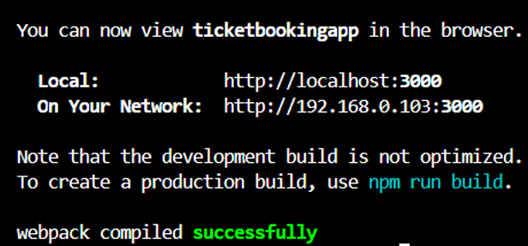
Guest View:
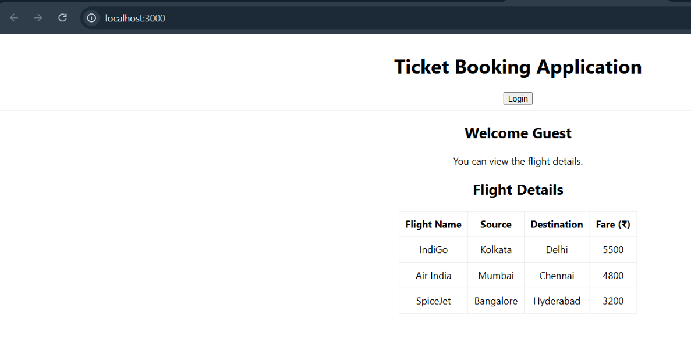
User View:
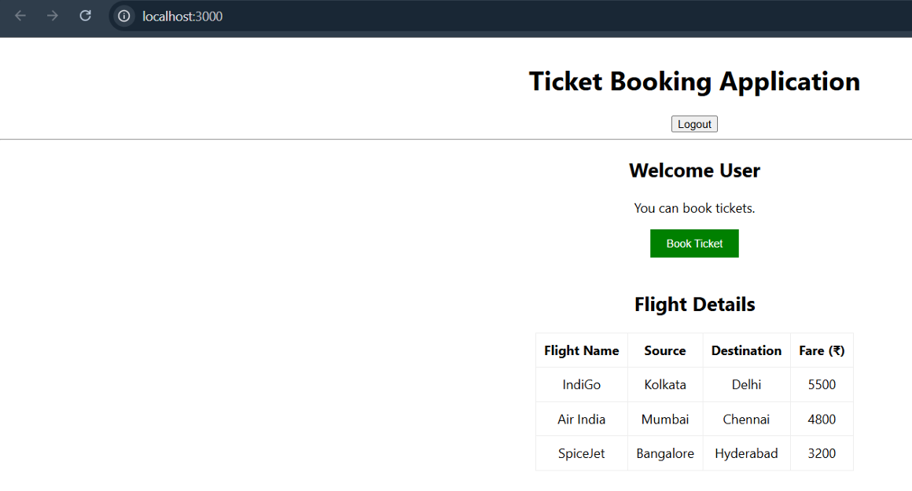
Conclusion:
The Ticket Booking Application was successfully implemented using ReactJS. The application demonstrates conditional rendering by displaying different interfaces for Guest and User while reusing the FlightDetails component.

